Further Examples

- Tweets

- Sloane Crosley demonstrates how jocular and voicey tweets can grow your following:

- Sloane Crosley (@askanyone): I have sprung from the womb of someone who e-mails in fluorescent comic sans. (53 Likes, 17 Retweets)

- Sloane Crosley (@askanyone): Next time your boyfriend forgets your birthday, remember that a guy in solitary confinement sent Amanda Knox flowers. (311 Likes, 63 Retweets)

- Neil Gaiman directly promotes his upcoming book in an enticing way. Like most authors, he re-tweets his publisher’s promotional tweets as well as re-tweets interviews, guests posts on blogs, etc.

- Neil Gaiman (@neilhimself): Less than 60 days until THE VIEW FROM THE CHEAP SEATS is published! 500 pages of me talking about the things I love. [promotional link] (81 Likes, 11 Retweets)

- Jen Lancaster promotes her upcoming book in a way that is unobtrusive and humorous but also effective at stirring interest:

- Jen Lancaster (@altgeldshrugged): 92,157 words later, the new memoir is complete and I can finally take a shower. (238 Likes, 13 Retweets)

- Margaret Atwood often re-tweets on news and cultures, but she also creates contests and hashtags to engage her audience:

- Margaret Atwood (@MargaretAtwood): OK #TwitterFiction, here we go. It’s [her short story] a found object made of the descriptors culled from previews of plane movies. I wrote it on a plane. ☺ (54 Likes, 29 Replies)

- Celeste Ng demonstrates that it’s not always about your book – it’s about your personality and voice. Pictures often get more engagement – but we’re not including many because of space constraints here):

- Celeste Ng @pronounced_ing: Couldn't remember the name "GQ" so I said "Man Vogue" and my husband actually understood what I meant, AMA (5 replies 6 retweets 203 likes)

- Celeste Ng @pronounced_ing: Feeling this so hard today. (8 replies 292 retweets 1,256 likes)
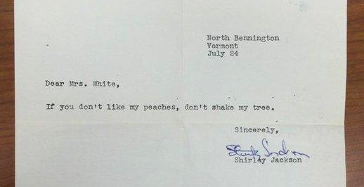

- R.L. Stine
has a fun recurring twitter segment where he shares ridiculous/funny/crazy news stories under the hashtag #truehorror: twitter.com/RL_Stine

- Angie Thomas tweets about activism, pop culture, and her books – plus she found her agent from a Twitter hashtag Q&A session: https://twitter.com/angiecthomas

Example Facebook Author Pages

- Facebook

- www.facebook.com/danielsilvabooks/
- www.facebook.com/LindaFairstein/
- www.facebook.com/MichaelConnellyBooks/
- www.facebook.com/authorJaneGreen/
- www.facebook.com/marykayandrewsauthor/
- www.facebook.com/lauralippman/
- www.facebook.com/annaquindlen/
- www.facebook.com/AliceHoffmanAuthor/
- www.facebook.com/JulieKlamAuthor/?fref=ts
- www.facebook.com/AndrewSolomon.author/
- www.facebook.com/GilbertLiz/
- www.facebook.com/GretchenRubin/
- www.facebook.com/JhumpaLahiriAuthor/
- www.facebook.com/junotdiaz.writer/
- www.facebook.com/isabelallende/

Facebook Post Example

This post utilizes multiple images and tags the publisher:

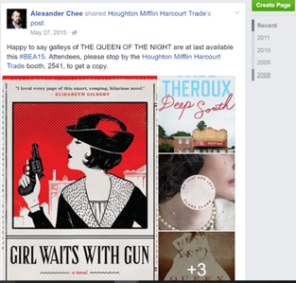

Example Author’s Instagram profile

- Instagram
