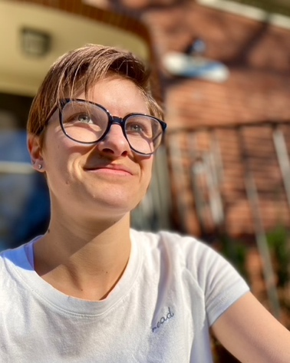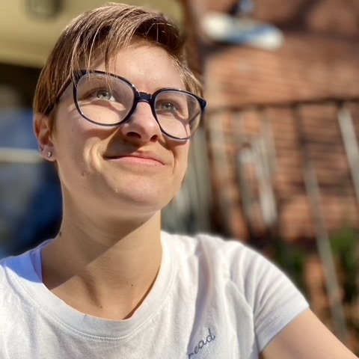
(Rectangular) Photo Credit: Me (Square) Photo Credit: Also Me

Name: Emily E. Dickson
Pronouns: she/they/e/ey

Contact: mlereads@gmail.com
Agent: Natalie Lakosil natalie@bradfordlit.com
Publicist: Name Surname fakeemail@company.com

Social Media Links:

Twitter: @mlereads
Instagram: @mlereads

Buy Links:

Barnes & Noble:
Bookshop:
IndieBound:
Book Depository:
Amazon:
Little Shop of Stories:
Sea Howl Bookshop:
Where the Sidewalk Ends Bookstore:

Short Bio:

Emily E. Dickson (she/they/e/ey) is mostly a fool, but she really hopes this document template helps. They wrote their first book at age 3 months. This is an exaggeration. Eir published books do not exist yet, but if they did, they would likely feature Middle Grade Anxiety, Queer Yearning by the Sea, Thesbians, and Sailing Away: Escaping Existential Dread by Stowing Away on Someone Else’s Boat.

Standard Bio:

Emily E. Dickson (she/they/e/ey) is mostly a fool, but she really hopes this document template helps. If it does not help, please let her know, so that she can provide additional advice. They wrote their first book at age 3 months. This is an exaggeration. They wrote their first book that exceeded 20,000 words at age 14. This is not an exaggeration. It was a Revolutionary War epic for a school assignment. Eir published books do not exist yet, but if they did, they would likely feature Middle Grade Anxiety, Queer Yearning by the Sea, Thesbians, and Sailing Away: Escaping Existential Dread by Stowing Away on Someone Else’s Boat. Wherever Emily is now, ey would prefer to be reading on a beach somewhere, with gentle waves whooshing in the background.

<<insert high-res book covers OR deal announcements here>>

Book Descriptions:

Middle Grade Anxiety: A twelve-year-old nonbinary bean has a lot of anxiety and probably also a dog. They eat a LOT of Nutella on toast and do NOT do their homework because of undiagnosed ADHD. But will they overcome?

Queer Yearning by the Sea: Two queer teenagers find themselves in the same coastal town for the summer and must reckon with each other’s secrets—and their own—if they want to find the lost and ancient pirate treasure of local legend…before they’re forced to go back to their ordinary lives.

Thesbians: Queer theatre kids. Need I say more? (Okay, so, when their beloved theatre teacher is fired under mysterious circumstances, a group of misfit teens must rally support for their teacher’s reinstatement while also secretly attempting to put on their canceled production of Spring Awakening: The Musical without any faculty or otherwise adult supervision.)

Sailing Away: Escaping Existential Dread by Stowing Away on Someone Else’s Boat: Welp. Unfortunately, what this book tells us is that it doesn’t work. But a lot of hijinks occur for sure when they are inevitably discovered by the captain.

Praise:

“Wow, Emily E. Dickson’s books are so good it’s like they don’t even exist.” –Publishers Weekly

“We never would’ve guessed that Emily E. Dickson’s Queer Yearning by the Sea would feature actual queer yearning by the sea. We are so delighted to be proven wrong.” –Kirkus Reviews

“I honestly didn’t think this would ever happen for you. Good job, I guess.” –my brother

“Bark bark snuffle snuffle woof woof bark.” –Luna, my best dog

